Field Crops Research, 34 (1993) 23-36 Elsevier Science Publishers B.V., Amsterdam
ABSTRACT
23
K.G. Cassmanª, P.W. Singleton ^{b} and B.A. Linquist^{b} ªInternational Rice Research Institute, Manila, Philippines ^{b}NiFTAL Project, 1000 Holomua Ave, Paia, Hawaii, USA (Accepted 14 December 1992⁾
Although biological N₂ fixation (BNF) by legumes can provide significant N inputs to crop systems on highly weathered tropical soils, potential inputs from BNF largely depend on soil P supply. We compared the cumulative effects of P input regimes on yield, N and P budgets, and soil P availability in four consecutive soybean crops in a 2-year period on a Humoxic tropohumult. In each crop cycle, nodulating (nod) and nonnodulating (nonnod) isolines were subplots in P-regime mainplots (kg P ha⁻¹ by crop cycle): P_{o}= control without P inputs; LP= 50, 35, 35, 35; MP= 100, 70, 70, 70; and HP= 300, 210, 210, 210. Seed yields of the nod isoline in the HP regime were 3700 kg ha⁻¹ in the two summer seasons and 2400 to 2500 kg ha⁻¹ in the fall seasons, with a mean increase of 85% compared to yields of the nod P_{o} control. Nonnod seed yields and N accumulation were unaffected by the P regime, averaging 870 and 48 kg ha⁻¹, respectively. The contribution of BNF to nod soybean N assimilation was linearly related to P uptake, and mean P uptake by nod plants was 60% greater than by nonnod soybean, despite 35% greater root length of nonnod plants at 0-50 cm depth. For the four crop cycles, total BNF input to the system ranged from 330 kg N ha⁻¹ (P_{O}), or 65% of total aboveground N, to 710 kg N ha⁻¹ (HP), which was 78% of total aboveground N. After accounting for P removal at harvest, a net P input of just 99 kg P ha⁻¹ after four crops increased cumulative seed yield by 3600 kg ha⁻¹ and BNF by 227 kg N ha⁻¹ in the LP treatment. A positive net P balance also resulted in (1) an increase in extractable P in the 0 to 25 cm topsoil, (2) a reduction in the proportion of P that would be fixed from subsequent additions as indicated by a shifted P sorption isotherm, and (3) greater apparent P uptake efficiency from applied fertilizer in subsequent crop cycles. As a result, the yield response of nod soybean per unit P input increased from 13 kg seed kg⁻¹ P applied in the first crop to 44 kg seed kg⁻¹ P applied in the fourth crop of the LP treatment. Cumulative effects of this magnitude emphasize the need to consider the longer-term nutrient balance of the crop system in developing cost-effective P management strategies on highly weathered soils. The potential for greater P input use efficiency with time when inputs exceed outputs means that farmers' average and marginal return from investment in P fertilizer will also increase with time.
Correspondence to: Dr. K.G. Cassman, International Rice Research Institute, P.O. Box 933, 1099 Manila, Philippines.
0378-4290/93/$06.00 © 1993 Elsevier Science Publishers B.V. All rights reserved.
0378-4290/93/$06.00 © 1993 Elsevier Science Publishers B.V. All rights reserved.
Input/output analysis of the cumulative soybean response to phosphorus on an Ultisol
2
INTRODUCTION
Phosphorus (P) deficiency is a major limitation to crop production on the highly weathered oxisols and ultisols which dominate upland regions in the tropics. These soils often have a strong phosphate fixation character and require large inputs of P to alleviate P deficiency for production of food crops. Sustained productivity depends on the balance of P inputs versus P outputs.
Most research about the management of P fertility on highly weathered soils concerns the residual yield response to P application rates and placement methods to increase the uptake efficiency from applied fertilizer (Kamprath, 1967; Yost et al., 1979, 1981; Smyth and Cravo, 1990). Less is known about the cumulative effects that may accrue from P applications made to consecutive crop cycles. Because the strength of phosphate adsorption to soil particles decreases as the quantity of adsorbed phosphate increases (Mekaru and Uehara, 1972; Barrow, 1978), a management strategy that provides P inputs in excess of P removal with harvested grain and crop residues should result in greater P uptake and yield response per unit of P applied to subsequent crops. This phenomenon should be most evident on P-deficient soils with a large sorption capacity.
Highly weathered soils in the humid tropics are also commonly N deficient, and BNF of legume crops often represents an important input to the cropping system. Legume BNF, however, is very responsive to the soil P availability (Graham and Rosas, 1979; Cassman et al., 1980, 1981) so that the balance of P inputs and outputs exerts a large influence on the N economy of these systems. Soil fertility management strategies must therefore consider both the short- and longer-term impact of P inputs on economic yields, the N contribution from BNF, and changes in the soil resource base. The goals of our research were (1) to quantify the cumulative yield response of soybean (Glycine max (L. ) Merr. ) to P applied in each of four consecutive crop cycles on a highly weathered Ultisol by monitoring the P balance and N₂ fixation, and (2) to test for the existence of an amplified yield response per unit P applied, which may result from a strategy of providing P inputs in surplus of removal to reduce the P sorption affinity of the soil.
MATERIALS AND METHODS

Site description, experimental design, and crop management

The experimental site is 320 m above sea level on the island of Maui, Hawaii (20°54'N, 156°18'W). Mean annual rainfall is 1800 mm. The soil is classified as a Haiku clay (clayey, ferritic, isohyperthermic Humoxic Tropohumult) weathered from basic igneous rock and volcanic ash. Initial characteristics of surface soil from 0-25 cm were: pH of 4.8 (1:1 soil/H₂0), bulk density of 1.25 g cm⁻³, 32.9 g kg⁻¹ organic carbon as measured by ignition
K.G. CASSMAN ET AL.
SOYBEAN RESPONSE TO PHOSPHORUS
3
on a LECO CHN-600 analyzer (Sheldrick, 1986), and total N of 2.5 g kg⁻¹ determined by Kjeldahl digestion (Bremner and Mulvaney, 1982). Subsurface soil from 25-50 cm had a pH of 4.6, bulk density of 1.28 g cm⁻³, organic carbon of 28.8 g kg⁻¹, and total N of 1.8 g kg⁻¹. Soil P status was measured by the double-acid (DA) method used on highly weathered soils in Brazil and in the southeastern USA (0.05 M HCl +0.05 M H₂SO₄, 1:10 soil/solution, 5 min shaking). Initial DA-extractable P was 0.9 mg kg⁻¹ at 0-25 cm, and 0.6 mg kg⁻¹ at 25-50 cm. A CR-21 micrologger (Campbell Scientific, Inc., Logan, Utah) installed at the site recorded solar radiation, temperature, and rainfall at 30-min intervals.
Treatments were applied to the same plots in four consecutive cropping seasons arranged as a split plot completely randomized block design with four replicates. Mainplots were P-input regimes: a control without P inputs (P_{O}), a low P-input treatment (LP) that received 50, 35, 35, and 35 kg P ha' in consecutive crop cycles, a moderate P-input regime (MP) of 100, 70, 70, and 70 kg P ha', and a high P-input regime (HP) with 300, 210, 210, and 210 kg P ha⁻¹ applied to the four crop cycles. The P source was treble super-phosphate, which was broadcast and incorporated with a rotovator approximately 1 month before sowing each crop. Subplots were nodulating (nod) and nonnodulating (nonnod) soybean `Clark' isolines.
The four crop cycles included two fall seasons and two summer seasons (Table 1). At sowing, a peat-based inoculum containing strains USDA 110, 136b, and 138 was coated on seeds with gum arabic as a sticker. Subplots were 3 X 6 m with five rows spaced 0.6 m apart. Based on mean seed weight and in vitro germination percentage, seeding rates delivered 24 viable seed m⁻¹ of row for a targeted density of 400 000 plants ha⁻¹. To raise pH of surface soil to 5.5, 5 t ha⁻¹ of finely ground agricultural lime (Ca(OH)₂) was surface applied and incorporated one month before the first crop. An additional 3 t ha⁻¹ was applied in the same fashion before the third crop cycle to maintain pH at 5.5. One week before sowing each crop, 200 kg K and 50 kg Mg ha⁻¹ were broadcast and incorporated. The micronutrients Zn (10 kg ha⁻¹), B (0.5 kg ha⁻¹), and Mo (0.5 kg ha⁻¹ ) were applied and incorporated before the first and fourth crop cycles. At maturity, all aboveground crop biomass was removed. Only roots were recycled.
Weed and insect pests were controlled as required in each crop cycle to avoid yield reduction. Tensiometers were placed at several locations in each block. A surface drip irrigation system with a single line for each soybean row provided supplemental irrigation when tensiometer readings indicated - 50 to - 60 kPa at 0.2 m depth.

Plant and soil measurements
At harvest maturity when 95% of pods had lost their green color, 2 m of the inner three rows were cut at the soil surface for determination of seed and
K.G. CASSMAN ET AL.
haulm yields. Haulms included stems, leaves, and pod walls recovered after threshing. All plant samples were dried to constant moisture at 70ºC before dry weights were measured. After grinding, tissue samples were analyzed for total N by ignition on the LECO CHN-600, and for P after Kjeldahl digestion (Throneberry, 1974).
Roots were sampled at the R-5 growth stage (Fehr et al., 1971) in the summer season 1990 by taking eight 1.6-cm diameter cores from 0-0.125, 0.125-0.250, and 0.250-0.500 m depths in each subplot. All cores were taken at a distance of 0.2 m from the plant row. Roots were washed free of soil on a 0.5mm sieve, root length determined by the grid-intersect method of Tennant (1975), and oven-dry weights were recorded. Large roots greater than 1.5 mm diameter were not included in the measurements of root length and mass.
Soil was sampled from 0-25 and 25-50 cm at the R-5 stage in each crop cycle. Soils were air-dried, passed through a 2-mm sieve, and analyzed for pH and DA-extractable P. To examine the influence of the P-input regime on the relationship between adsorbed and DA-extractable P, air-dry surface soil from each subplot sampled in the last crop cycle (fall, 1990) received 0, 62, 124, or 248 mg P kg' as a Ca (H₂PO₄) ₂ solution 1:1 (soil/solution ), followed by air-drying for 10 days at 30ºC. After air-drying, DA-extractable P was measured as described above. Sorbed P was calculated as the difference between added P minus the increase in DA-extractable P that resulted from P addition.

Phosphorus and nitrogen balance
Total N and P in aboveground biomass at maturity were calculated from dry matter yields and N and P concentrations in seed and haulms. Estimates of N derived from N₂ fixation were based on the total N difference between nod and nonnod isolines in each P-regime main plot. Apparent uptake of applied P was estimated by the difference in total P accumulation at a given rate of applied P minus the total P of the appropriate P_{o}-isoline treatment.
Statistical analyses
Analyses of variance (AOV) for soybean yield, tissue nutrient concentrations and total nutrient accumulation, and DA-extractable soil P were analyzed as a split-split plot design with P-regimes as mainplots, isolines as subplots, and the four cropping seasons as repeated measures at the sub-subplot level. Root measurements, made only in summer 1990, were analyzed as a split plot AOV. Relationships between N₂ fixation versus P accumulation, P accumulation of nod versus nonnod isolines, and adsorbed versus DA-extractable P were evaluated by regression techniques that tested for linear and curvilinear fit of the data.
4
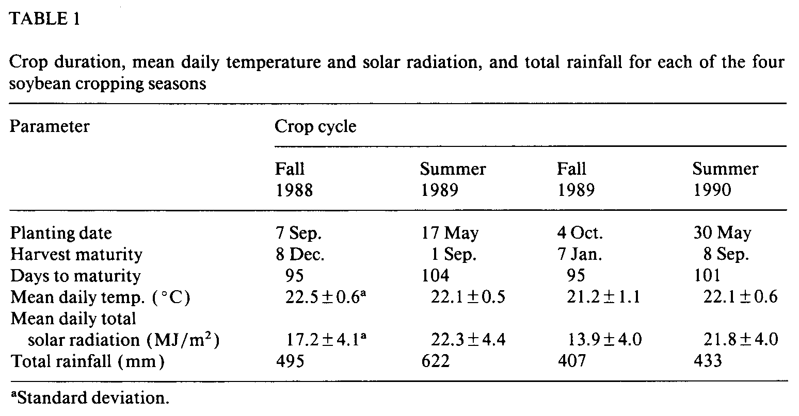
SOYBEAN RESPONSE TO PHOSPHORUS
5
RESULTS
Growth conditions
Mean daily temperature was similar in each of the four cropping seasons (Table 1). Solar radiation, however, was considerably less in the fall seasons during reproductive growth from early flowering (R-2 stage) to physiological maturity. Mean daily radiation averaged 22.4 MJ m⁻² in the two summer seasons versus 13.5 MJ m⁻² in the two fall seasons. The summer crop of 1989 had more favorable growth conditions than the summer of 1990 due to 10% greater solar radiation between R-2 to R-6 growth stages.
Yield response and soil phosphorus
Maximum seed yield of the nod isoline was 3700 kg ha⁻¹ in the summer seasons versus 2400 to 2500 kg ha⁻¹ in the fall (Fig. 1) . The slope of the yield response to applied P was more gradual in the fall seasons: relative yield in LP treatments averaged 76% of the highest yield (HP) in the two fall crops versus an 88% mean relative yield for the LP regime in the two summer seasons. The magnitude of the yield response between the HP and P_{o} treatments for the nod isoline was 1870 kg ha⁻¹ in summer 1990, and ranged from 1170 to 1270 kg ha⁻¹ in the other crop cycles. Seed yield of the nonnod isoline was not affected by the P-input regime (P=0.26) although the mean yield of the nonnod isoline differed by cropping season (P< 0.001) with most of this effect due to a lower yield in the first crop cycle.
Extractable soil P did not differ in nod and nonnod isoline subplots with equivalent P inputs (P=0.92). A decline in the DA-extractable soil P of P_{o} control treatments was not detected after the four soybean crop cycles (Fig. 2). In contrast, DA-extractable P of surface soil increased with each seasonal
6
P application made in the LP, MP, and HP treatments. There was little increase in soil P below 25 cm except in the HP treatment.
Laboratory measurements of P sorption in surface soil from the P_{O} and MP
K.G. CASSMAN ET AL.
7
Fig. 3. Phosphorus sorption in relation to DA-extractable P in soil from 0-25 cm sampled at the R-5 growth stage of the fourth soybean crop in summer 1990. Data points represent treatment means from nod (open circles) and nonnod (closed circles) subplots for soil from control treatments without P input (P_{o} soil) and from the MP treatment that received cumulative net P inputs of 250 kg P ha⁻¹ (MP soil).
plots that were sampled at the R-5 stage of the fourth crop cycle demonstrate the curvilinear nature of P fixation in relation to the quantity of added P (Fig. 3). In soil from both treatments, the proportion of added P that was adsorbed beyond extraction decreased as the rate of P addition increased. Likewise, the cumulative effect from the net P input of approximately 250 kg P ha⁻¹ to soil from the MP-regime in nod and nonnod plots (Table 2) reduced the slope of the sorption curve so that less P was fixed per unit P applied compared to the P_{o} soil.
Phosphorus balance, N₂ fixation, and root development
Total P accumulation in aboveground biomass was greater in summer than in the fall for both isolines (Table 2). Total P accumulation was similar in the two fall seasons for comparable P-regime treatments even though P input rates were reduced by 30% in fall 1989. Because all aboveground biomass was removed from the field at physiological maturity, the cumulative net P balance for the four crop cycles ranged from a deficit of 30 kg P ha⁻¹ in the P_{o}nod treatment to a positive net input of 880 kg P ha⁻¹ in the HP-nonnod plots.
Although P uptake by the nonnod isoline increased with greater inputs of P (Table 2), N accumulation of the nonnod isoline was not influenced by the P regime (Table 3). By contrast, total N of the nod isoline was very sensitive to the P supply with a mean difference between HP and P_{o} treatments of 83 kg N ha⁻¹ in fall seasons and 228 kg N ha⁻¹ in the summer seasons. Of the increased N accumulation by nod soybean due to greater P supply, 90 to 96% was derived from BNF. For example, total N accumulation for the four crops
8
K.G. CASSMAN ET AL.
SOYBEAN RESPONSE TO PHOSPHORUS
9
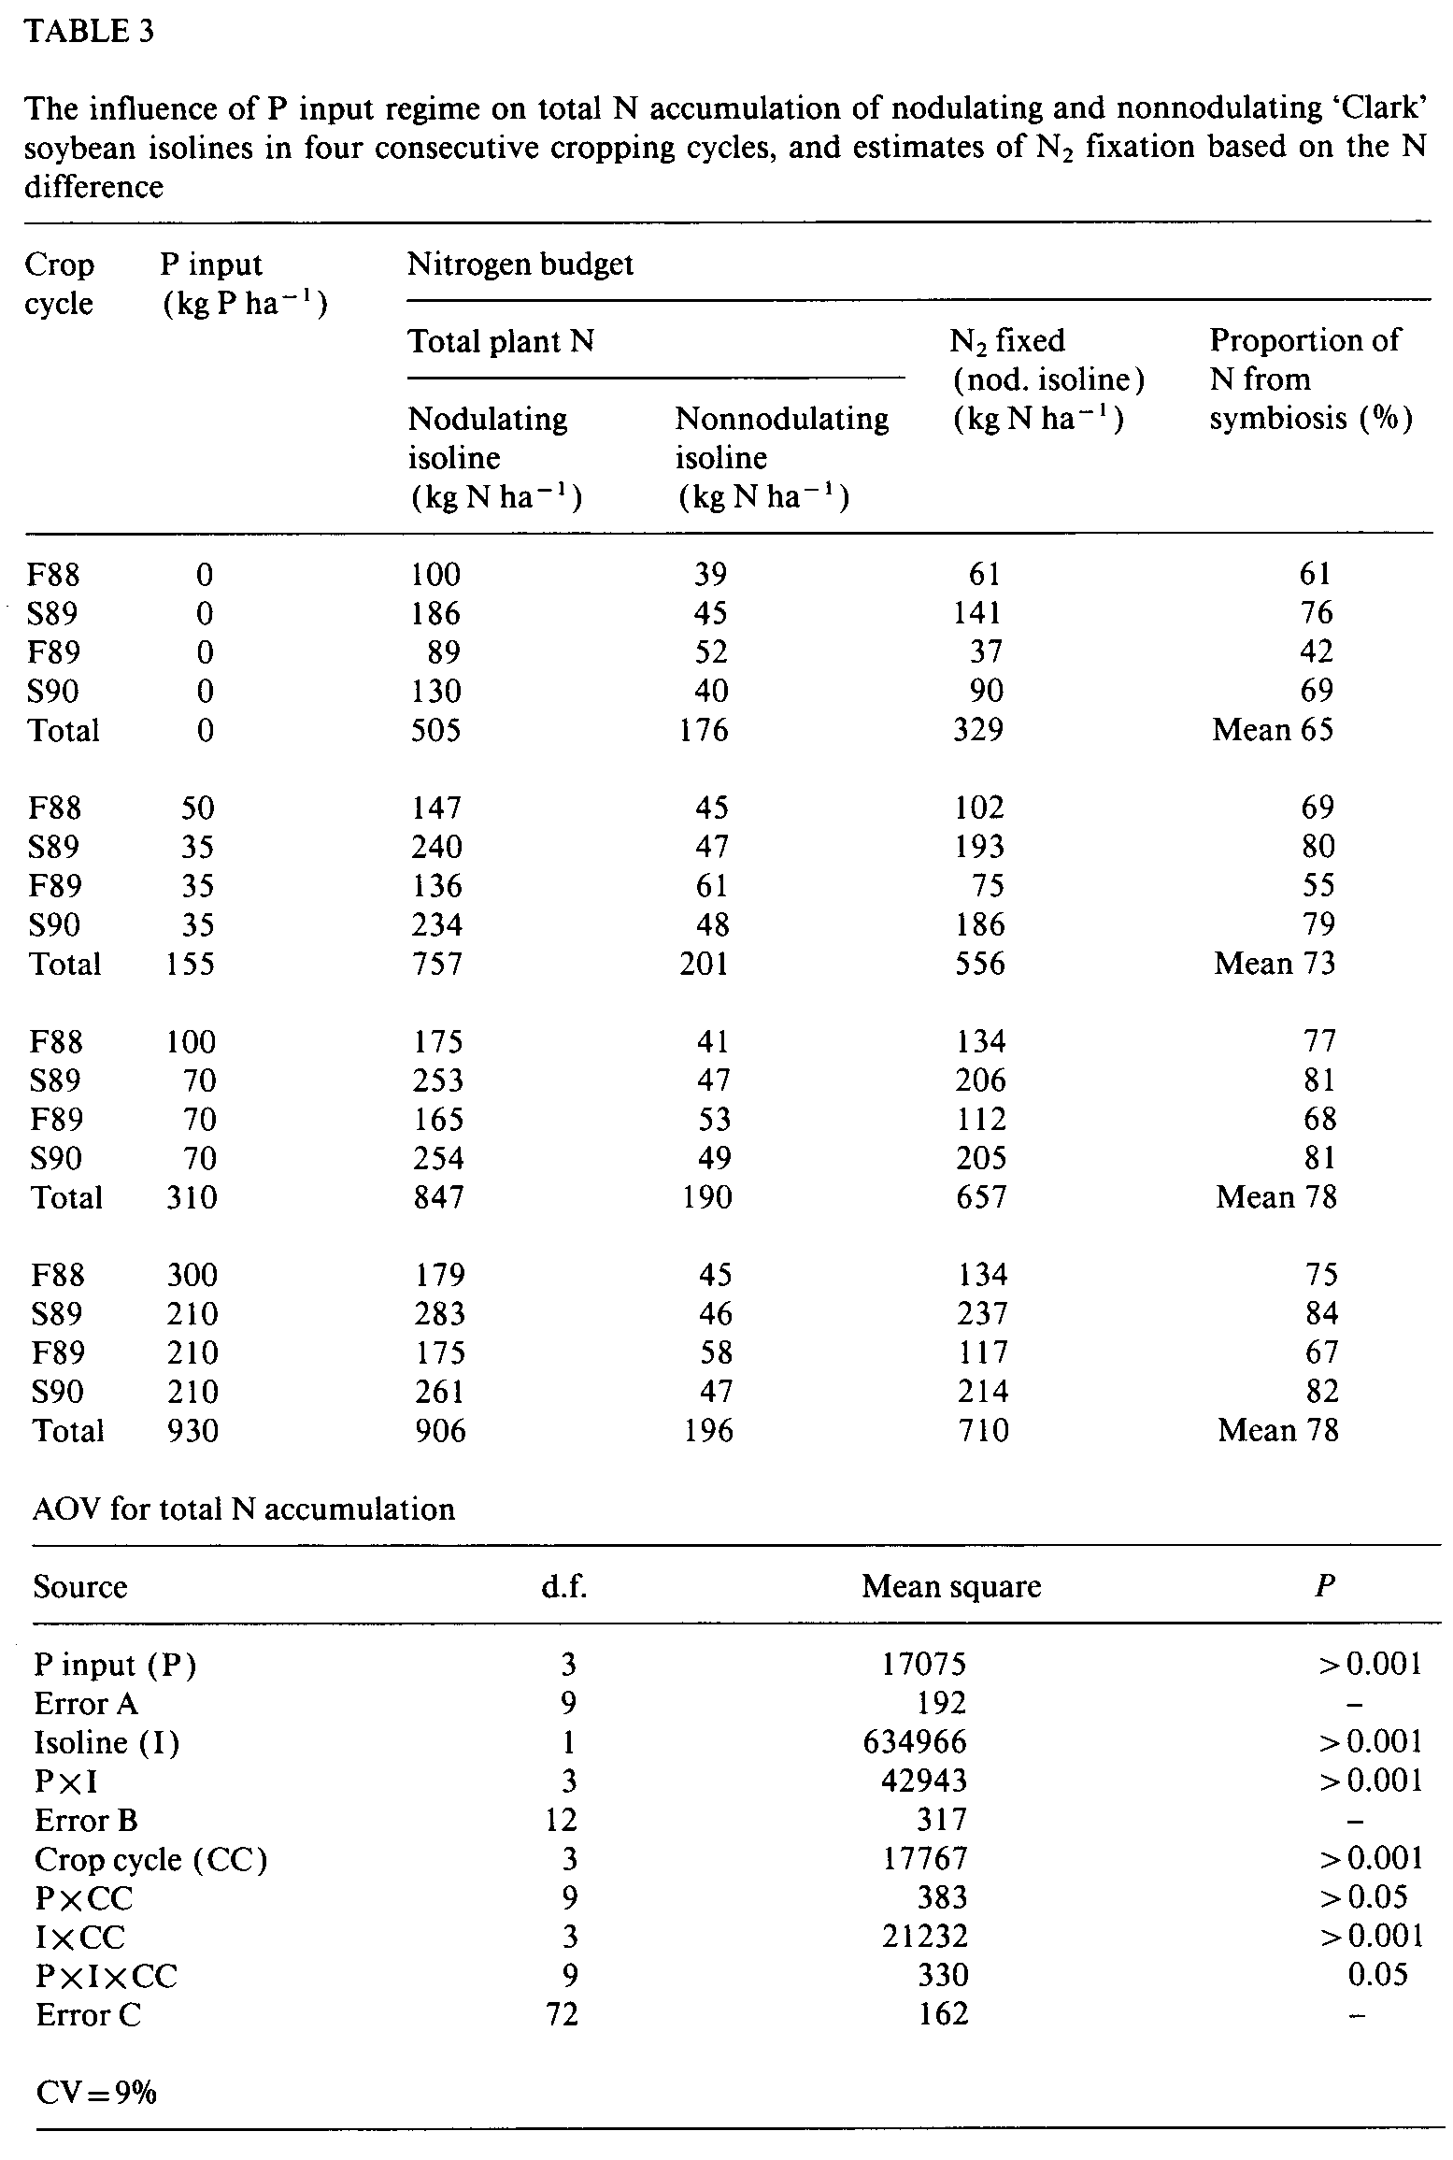
10
by the nod isoline in the MP treatment was 342 kg N ha⁻¹greater than by P_{O} nod plants, and 328 kg N ha⁻¹ was attributable to BNF. The N difference method, however, probably underestimated the actual BNF contribution due to the larger root system of nonnod plants (Table 4) which would provide an advantage for acquisition of available soil N.
There was a close linear relationship between BNF and P uptake of the nod isoline in all crop cycles (Fig. 4a). In turn, greater plant N supply as a result of the BNF contribution had a large, positive influence on P uptake when compared to the P acquisition by the N-deficient nonnod plants (Fig. 4b). In the two summer crops, for example, P uptake by nod plants was nearly double the P uptake of nonnod plants in MP and HP treatments (Table 2). Greater uptake by symbiotic soybean occurred despite a root system that had 13% less mass and 25% less root length in the 0-25 cm surface soil compared to the root development of the nonnod isoline (Table 4). The larger root system of the nonnod plant and growth that was severely limited by N deficiency re-
K.G. CASSMAN ET AL.
s
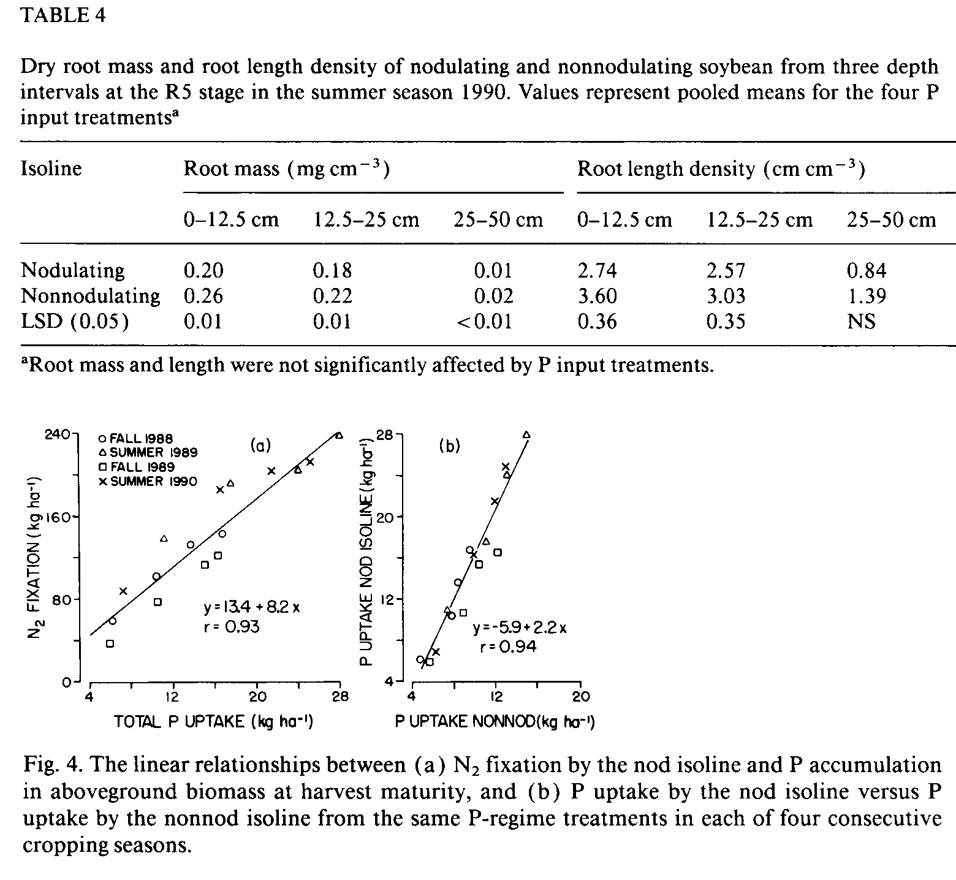
SOYBEAN RESPONSE TO PHOSPHORUS
11
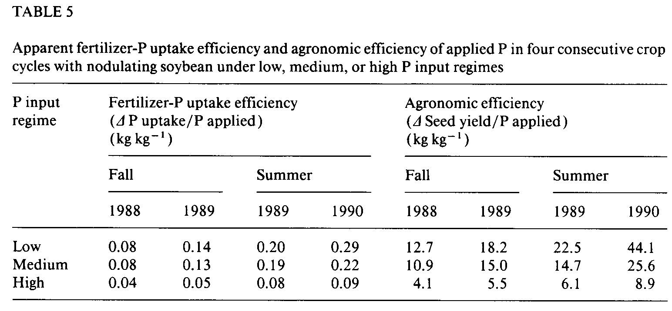
sulted in P enrichment of seed and vegetative tissues at maturity. Mean P concentration of nonnod seed was 8.3 g P kg⁻¹ versus 5.3 g P kg⁻¹ for nod seed (P<0.001). Nonnod stover averaged 2.3 g P kg⁻¹ compared to 0.8 g P kg' in nod stover (P< 0.001).
Measures of fertilizer-P efficiency
Apparent P uptake from applied fertilizer and agronomic efficiency (defined as the increase in seed yield per kg P applied) were greater in summer than in the fall (Table 5). In all seasons, efficiency of P uptake was lowest in the HP regime because of the large P surplus. Comparison of efficiencies by season indicates greater uptake efficiency and agronomic efficiency in the 1989 versus 1988 fall crop, and a similar increase in the 1990 summer versus the 1989 summer crop. Equivalent P-input regimes were imposed in both summer seasons which allows direct comparison of efficiency for the same quantity of applied P. For the two fall crops, this comparison is confounded by different rates of P input for the same P regimes in 1988 and 1989 (Table 2). Greater uptake and agronomic efficiency are still evident, however, in the MP treatment of fall 1989 which received 70 kg P ha⁻¹ compared to the LP treatment of fall 1988 which received only 50 kg P ha⁻¹.
DISCUSSION
The feasibility of improving soil fertility depends to a large extent on the costs and benefits realized from nutrient inputs. For most nutrients, crop yield response per unit nutrient applied decreases as the rate of application increases. On soils with a large P fixation capacity, however, results from the present study indicate that a positive P input balance in previous crop cycles can lead to increased output/input efficiency in subsequent crops.
12
K.G. CASSMAN ET AL.
The amplification of nutrient use efficiency was greatest as DA-extractable soil P increased from 1 to 4 mg kg⁻¹ in P regimes with a low to moderate net surplus of P inputs versus exports. The range of 1 to 4 mg P kg⁻¹ DA-extractable soil P in which soybean yields were most sensitive to increased soil P status is similar to the P response of soybean reported on an oxisol with high clay content in Brazil (Lips et al., 1985). In this range of DA-extractable P, a small shift in the sorption isotherm can have a relatively large impact on P input requirements. For example, based on the bulk density of the 0-25 cm surface soil, the P_{O} soil in Fig. 3 requires a net P input of 71 kg ha⁻¹ to raise DA-extractable P to 2 mg P kg⁻¹from 1 mg P kg⁻¹. To achieve an equivalent 1 mg P kg⁻¹ increase in the MP soil, from 3 to 4 mg P kg⁻¹, a net P input of only 58 kg ha⁻¹ is needed, or about 20% less than for a comparable increase in the P_{O} soil.
An amplified output/input efficiency from a net P surplus in previous crop cycles is consistent with the nature of phosphate adsorption to oxide surfaces (Mekaru and Uehara, 1972; Barrow, 1978). In our study, supplying a modest net P input to each consecutive crop resulted in less P adsorption per unit of applied P, and reduced P sorption was reflected by greater P uptake efficiency and agronomic efficiency in subsequent crops. Because N₂ fixation by soybean was linearly related to P uptake, greater P uptake efficiency would also promote increased symbiotic N inputs to cropping systems on highly weathered soils.
Soybean root nodules form at the expense of root proliferation (Cassman et al., 1980). In the present study, root development of the nonnod isoline was significantly better than that of the nod isoline. But the capacity to overcome growth limitations from N deficiency greatly increased P uptake of the nod isoline (Fig. 4b) so that P uptake per unit root surface area was much greater in the nod isoline than by the nonnod root system. Feedback inhibition to P uptake by nonnod roots due to elevated tissue P concentration may have contributed to the reduced P uptake of the nonnod isoline.
In our study, supplemental irrigation was provided and nutrients other than P and N were not limiting. We recognize that highly weathered soils of the humid tropics are often deficient in other nutrients besides P and N, and may have other constraints such as aluminum toxicity and periods of water stress that occur under rainfed conditions. Such conditions would likely decrease the magnitude and increase the variance of a cumulative response to P, but the cumulative effects should still carry forward. Where drought is the primary limitation, nutrient inputs can be substitutive for water. For example, in the relatively harsh conditions of the Sahel, primary productivity of forage plant communities was limited more from N and P deficiency than low rainfall except in the most arid regions, and inputs of N and P increased the water use efficiency of the production system (Breman and de Wit, 1983).
The existence of an amplified response to P from a positive P-balance in
s
SOYBEAN RESPONSE TO PHOSPHORUS
previous crop cycles remains to be verified under on-farm conditions. Similarly, the influence of fertilizer placement methods on cumulative efficiencies of the production system is an important issue where planting methods allow localized nutrient application. Such determinations require an input/output analysis similar to the approach taken in the present study. For example, use of input/output analysis demonstrated an amplified response to potassium (K) applications made to consecutive cotton crops in an on-farm study conducted on a vermiculitic soil with a large K fixation capacity in California (Cassman et al., 1989).
The potential for greater output/input efficiency from a management strategy that provides a modest P surplus has important implications for the tropical uplands. With increasing population pressure in many regions, several researchers propose an evolution of present subsistence, slash and burn agriculture towards sedentary agro-forestry systems which include higher value perennial crops, food crops, and investment in soil conservation measures for erosion control (Sanchez and Benites, 1987; Garrity, 1993). Often these scenarios are discussed as "low-input" alternatives, or systems in which nutrient inputs must "balance" removal. At issue, however, is whether it is possible to make such a transition with a low-input strategy of nutrient replacement. On highly weathered acid-infertile soils, it is more likely that soil fertility must be increased during the transition process. The existence of an amplified P response on highly weathered soils would help justify the investment in soil improvement and conservation that is required for making the transition to a sustainable agriculture in the tropical uplands.
ACKNOWLEDGEMENTS
The authors recognize and appreciate the agronomic skills and careful lab work of Research Assistants Kevin Keane and Geoff Haines. Soil and plant P analyses performed by Mr. Dennis Bryant, Staff Research Associate, are also acknowledged. We thank Dr. Thomas George for helping with the initial phase of the field study.
REFERENCES
Barrow, N.J., 1978. The description of phosphate adsorption curves. J. Soil Sci., 29: 447-462. Breman, H. and de Wit, C.T., 1983. Rangeland productivity and exploitation in the Sahel. Science, 221: 1341-1347.
Bremner, J.M. and Mulvaney, C.S., 1982. Nitrogen-total. In: A.L. Page et al. (Editors), Methods of Soil Analysis, Part 2, 2nd ed. American Soc. Agron., Madison, WI, pp. 595-624. Cassman, K.G., Whitney, A.S. and Stockinger, K.R., 1980. Root growth and dry matter distribution of soybean as affected by phosphorus stress, nodulation, and nitrogen source. Crop Sci., 20: 239-244.
13
14
Cassman, K.G., Whitney, A.S. and Fox, R.L., 1981. Phosphorus requirements of soybean and cowpea as affected by mode of N nutrition. Agron. J., 73: 17-22.
Cassman, K.G., Roberts, B.A., Kerby, T.A., Bryant, D.C. and Higashi, S.L., 1989. Soil potassium balance and cumulative cotton response to annual potassium additions on a vermiculitic soil. Soil Sci. Soc. Am. J., 53: 805-812.
Fehr, W.R., Caviness, C.E., Burmood, D.T. and Pennington, J.S., 1971. Stage of development descriptions for soybeans, Glycine max (L.) Merrill. Crop Sci., 11: 929-931.
Garrity, D.P., 1993. Sustainable land use systems for the sloping uplands of southeast Asia. In: J. Ragland et al. (Editors), Technologies for Sustainable Agriculture in the Tropics. American Soc. Agron., Madison, WI (in press).
Graham, P.H. and Rosas, J.C., 1979. Phosphorus fertilization and symbiotic nitrogen fixation in common bean. Agron. J., 71: 925-926.
Kamprath, E.J., 1967. Residual effects of large applications of phosphorus on high phosphorus fixing soils. Agron. J., 59: 25-27.
Lins, I.D.G., Cox, F.R. and Nicholaides, J.J., 1985. Optimizing phosphorus fertilization rates for soybeans grown on oxisols and associated entisols. Soil Sci. Soc. Am. J., 49: 1457-1460. Mekaru, T. and Uehara, G., 1972. Anion adsorption in ferruginous tropical soils. Proc. Soil Sci. Soc. Am., 36: 296-300.
Sanchez, P.A. and Benites, J.R., 1987. Low-input cropping for acid soils of the humid tropics. Science, 238: 1521-1527.
Sheldrick, B.H. 1986. Test of the LECO CHN-600 determinator for soil carbon and nitrogen analysis. Can. J. Soil Sci., 66: 543-545.
Smyth, T.J. and Cravo, M.S., 1990. Phosphorus management for continuous corn-cowpea production in a Brazilian Amazon Oxisol. Agron. J., 82: 305-309.
Tennant, D., 1975. A test of a modified line intersect method of estimating root length. J. Ecol., 63:995-1001.
Throneberry, G.O., 1974. Phosphorus and zinc measurements in Kjeldahl digests. Anal. Biochem., 60: 358-362.
Yost, R.S., Kamprath, E.J., Lobato, E. and Naderman, G., 1979. Phosphorus response of corn on an Oxisol as influenced by rates and timing. Soil Sci. Soc. Am. J., 43: 338-343.
Yost, R.S, Kamprath, E.J., Naderman, G.C. and Lobato, E., 1981. Residual effects of phosphorus applications on a high phosphorus adsorbing Oxisol of Central Brazil. Soil Sci. Soc. Am. J., 45: 540-543.
K.G. CASSMAN ET AL.

